LESSON PLAN

Subject: Portuguese as non Mother Tongue (first level)

Duration: 90 minutes

Grade Level: 10th year, 16 and 17 years old

Title of the unit: the Portuguese Country

Learning Objectives:
Pupils should:
- Identify the pictures that can be associated to Portugal and know what they illustrate;
- Look up information on Internet to do a multiple choice questionnaire;
- Know the Portuguese country (history, geographic diversity, political system, culture, gastronomy, weather…)
- Make an oral presentation giving information about what the colleagues need or would like to have about their country, regions and hometown.

Methods and approaches:
- Dialogue with the pupils to introduce the subject of the unit;
- Identifying and labeling pictures;
- Pair work: answering a multiple choice questionnaire;
- Whole class work: correction

Classroom Resources:
- Pictures; map;
- Computer access;
- Internet access;
- Hand out: multiple choice exercise;
- Pencils; notebooks.

Web addresses:
http://vimeo.com/11651143
http://www.inportugal-tourism.com/visitar.htm
http://www.gastronomias.com/
http://www.visitportugal.com/Cultures/pt-PT/default.html
http://healthportugal.com/portugal-1/country-profile?set_language=en
http://cvc.instituto-camoes.pt/conhecer/mapa-etno-musical.html
http://www.portugalvirtual.pt/80drinkeat/regionsp.html
http://www.portugal-live.net/P/places/alentejo.html
http://conhecer_a_europa.blogs.sapo.pt/
http://europa.eu/abc/european_countries/eu_members/portugal/index_pt.htm

Evaluation
- Active participation in the classroom work
- Oral interaction
- Curiosity and interest
- Performance in the multiple choice exercise
- Performance in the correction of the multiple choice exercise
- Performance in the writing activity

Attachments
Activity 1: Which pictures do you associate with Portugal? Do you recognise
any? What do they illustrate?
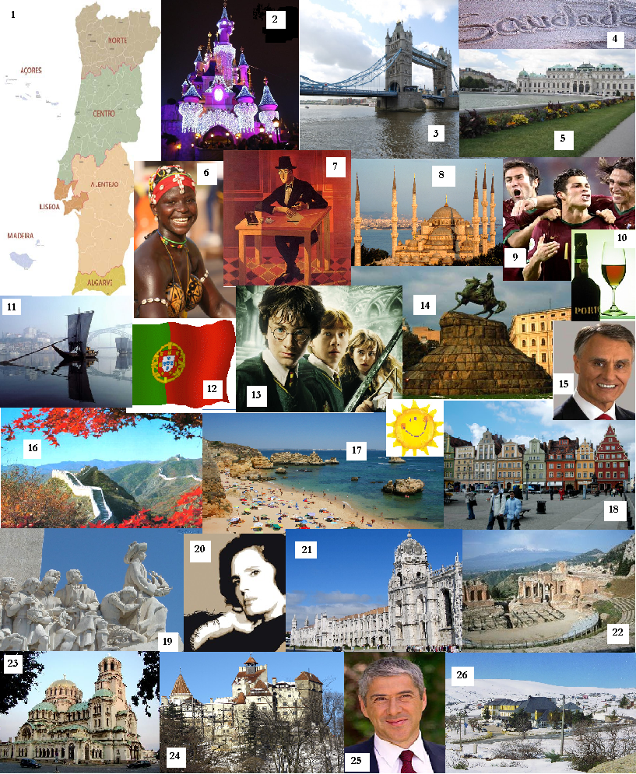

Activity 2: Learning more about Portugal on Internet (pair work)
Do the multiple choice questionnaire, ticking the correct answer.
- Where does Portugal lie?
Ο Eastern South America | Ο Eastern Europe
Ο Western Europe | Ο Western South America

- To which peninsula does Portugal belong?
Ο Scandinavian Peninsula | Ο Iberian Peninsula
Ο Balkan Peninsula | Ο Italic Peninsula

- Which country borders Portugal?
Ο France | Ο Spain
Ο Morocco | Ο Italy

- Which ocean surrounds Portugal?
Ο Indian Ocean | Ο Pacific ocean
Ο Atlantic ocean | Ο Arctic ocean

- Which is the highest point in mainland Portugal?
Ο Serra da Estrela | Ο Serra da Malcata
Ο Serra do Gerês | Ο Serra da Malveira

- Which two groups of island are Portuguese territory?
Ο Canary and Madeira islands | Ο Azores and Canary islands
Ο Sicily and Cyprus islands | Ο Madeira and Azores islands

- How many islands are there in the Azores?
Ο Seven | Ο Eight
Ο Nine | Ο Ten

- Which is the biggest and the shortest island in Azores?
Ο São Miguel and Corvo | Ο Faial and Flores
Ο Terceira and Corvo | Ο Pico and Faial

- Which is the capital of Madeira?
Ο Ponta Delgada | Ο Porto Santo
Ο Funchal | Ο Lisbon

- Which are the biggest Portuguese rivers?
Ο Tagus, Sado and Lima | Ο Tagus, Minho and Sado
Ο Tagus, Vouga and Gilão | Ο Tagus, Douro and Guadiana

- Which river goes by Lisbon?
Ο Douro | Ο Guadiana
Ο Tagus | Ο Vouga

- Which was Portugal’s first capital and which is the present one?
Ο Guarda and Lisbon | Ο Guimarães and Lisbon
Ο Coimbra and Lisbon | Ο Porto and Lisbon

- Which is the second biggest city in Portugal?
Ο Oporto | Ο Coimbra
Ο Faro | Ο Setúbal

- How is the first bridge over the Tagus river now named?
Ο Ponte 25 de Abril | Ο Ponte de Santa Catarina
Ο Ponte Vasco da Gama | Ο Ponte de D. Luís

- Which is the Portuguese political system?
Ο Monarchy | Ο Dictatorship
Ο Parliamentary Democracy | Ο None of these

- Which is the name of the Prime Minister of Portugal?
Ο Durão Barroso | Ο Pedro Passos Coelho
Ο Santana Lopes | Ο José Sócrates

- Who is the President of Portugal?
Ο Mário Soares | Ο Cavaco Silva
Ο Jorge Sampaio | Ο António Salazar

- Which are the main colours featured on the Portuguese flag?
Ο Green and red | Ο Red and yellow
Ο Green and orange | Ο Red and white

- How many inhabitants does Portugal have?
Ο About 12 million | Ο About 20 million
Ο About 15 million | Ο About 10 million

- Which is the Portuguese region that is well-known by its weather and beaches?
Ο Alentejo | Ο Algarve
Ο Beira litoral | Ο Trás-os-Montes

- Which is the capital of Algarve?
Ο Tavira | Ο Faro
Ο Loulé | Ο Lagos

- What’s the name of the Portuguese national anthem?
Ο The Alentejana | Ο The Vitoriosa
Ο The Portuguesa | Ο The Republicana

- Which is the Portuguese dominant religion?
Ο Christian: roman catholic | Ο Jewish
Ο Christian: Protestant | Ο No religion

- How many people speak Portuguese in the world?
Ο About 20 million | Ο About 100 million
Ο About 50 million | Ο About 200 million

- In which of these countries is Portuguese not spoken?
Ο Costa Rica | Ο Guinea
Ο Mozambique | Ο Angola

- Which is the typical Portuguese word?
Ο Saudade | Ο Freedom
Ο Book | Ο Friend

- In which year did Lisbon host a World Exposition?
Ο 1998 | Ο 1992
Ο 1989 | Ο 2004

- When did Portugal join the European Union?
Ο 1996 | Ο 1997
Ο 1995 | Ο 1992

- In which Portuguese cities can we find a bridge built by Gustav Eiffel?
Ο Faro | Ο Porto and Gaia
Ο Castelo Branco | Ο Lisbon and Almada

- Which village in Lisbon area is a UNESCO world heritage site?
Ο Belém | Ο Cascais
Ο Sintra | Ο Estoril

- Where can we visit the roman temple Diana?
Ο Beja | Ο Portalegre
Ο Évora | Ο Coimbra

- Which is the Lisbon tourist site, located in Belem, and built in memory of Vasco da
Gama’s voyage to India by king D. Manuel I, in the beginning of 16 th century?
Ο National Palace | Ο St. Jerónimo Monastery
Ο Belem Cultural Centre | Ο St. George’s Castle

- Who were the first and the last king of Portugal?
Ο D. Afonso Henriques and D. Manuel II | Ο D. Filipe I and D. Manuel II
Ο D. João IV and D. Carlos | Ο D. João I and D. Luís

- Which century began the Portuguese discovers?
Ο 11th century | Ο 13th century
Ο 17th century | Ο 15th century

- What is the name of the Portuguese architectural style appeared in XV th century?
Ο Neoclassical style | Ο Baroque style
Ο Gothic style | Ο Manueline style

- What was the bad event that happened to Portugal’s capital in 1755?
Ο Tornado | Ο Earthquake
Ο Big fire | Ο Terrorist attack

- Who is the 16th century Portuguese poet that wrote The Lusíadas?
Ο Padre António Vieira | Ο Fernão Mendes Pinto
Ο Luís de Camões | Ο Pêro Vaz de Caminha

- Which of these Portuguese writers are internationally known?
Ο Fernando Pessoa and José Saramago | Ο Cesário Verde and Ítalo Calvino
Ο Florbela Espanca and Garcia Lorca | Ο Isabel Allende and Jorge Amado

- To which Portuguese writer was Nobel Price awarded in 1998?
Ο Gonçalo M. Tavares | Ο Fernando Pessoa
Ο António Lobo Antunes | Ο José Saramago

- Which is the most popular sport in Portugal?
Ο Soccer | Ο Athletics
Ο Cycling | Ο Basketball

- Which is, at the moment, the most famous Portuguese player?
Ο Figo | Ο Dani
Ο José Mourinho | Ο Cristiano Ronaldo

- Which of the Portuguese below is not known internationally?
Ο Jorge Cruz, in Architectural | Ο Mariza, in Fado
Ο José Mourinho, in Football | Ο Paula Rego, in Painting

- Which are the three typical Portuguese products?
Ο Cork, pickles and whiskey | Ο Tiles, wine and tourism
Ο Textiles, coca-cola and shoes | Ο Tourism, pizza and sardine

- Which are the typical Portuguese dishes?
Ο Cozido de grão, bacalhau, gaspacho | Ο Caracóis, Chili, Pizza
Ο Kebab, Quiche, Paella | Ο Cuscuz, Sushi, Cachupa

- What is the most famous Portuguese wine?
Ο Alentejo wine | Ο Oporto wine
Ο Algarve wine | Ο Lisbon wine

- What are the “rabelos”?
Ο Sailing vessels that carry Porto wine | Ο Bull’s race
Ο Roman castles | Ο Old bridges

- Which is the Portugal currency?
Ο Peseta | Ο Dollar
Ο Escudo | Ο Euro

- What’s the name of the typical Portuguese music?
Ο Hip-Hop | Ο Funk
Ο Tango | Ο Fado

- Which are the rainiest months in Portugal?
Ο December and January | Ο November and December
Ο January and February | Ο October and November

- Which are the hottest months in Portugal?
Ο From March to June | Ο From April to July
Ο From March to July | Ο From June to September

Activity 3: Correcting the multiple choice questionnaire.

Activity 4: Writing a letter to their family abroad presenting Portugal. (Students should
make use of the information from the multiple choice questionnaire)

Homework:
Research and writing:
- Look up information on Internet about your country, region and hometown;
- Find pictures of typical places and people of your country. Think of monuments, major towns, food, drinks, sports, attractions, entertainment, weather …
- Make an oral and power point presentation to the class with your assignment and see if your classmates can answer some questions about your own country.

Support web addresses to do the homework:
Austria: http://pt.wikipedia.org/wiki/Geografia_da_%C3%81ustria
http://pt.wikipedia.org/wiki/Turismo_na_%C3%81ustria
http://www.colonialvoyage.com/paesi/pt/austria/index.html
China: http://www.tg3.com.br/historiadachina/
http://viagem.hsw.uol.com.br/china1.htm
http://www.suapesquisa.com/paises/china/
Guinea: http://pt.wikipedia.org/wiki/Guin%C3%A9-Bissau http://www.ipad.mne.gov.pt/index.php?option=com_content&task=view&id=53&Itemid=84
Ukraine: http://pt.wikipedia.org/wiki/Ucr%C3%A2nia
http://www.atlas-viagens.pt/destino.asp?destinoID=124

Class plan by: Maria Antonieta Couto
Escola Secundária 3EB Dr. Jorge Correia – Tavira
Portugal
May 2010

