



# **Intercultural Competences Across The School Curriculum**

## gre1.gif (5468 bytes)Bulgaria  bulgaria_mwjk.gif (9048 bytes) Romania  romaniamw.gif (10384 bytes)    Turkey turkey-white.gif (5603 bytes)   Greece

## Poland  poland.gif (7357 bytes)  Italy    itca1.gif (4219 bytes)         Portugal    portugal.gif (7364 bytes)

"This project has been funded with support from the European Commission. This publication reflects the views only of the author, and the Commission cannot be held responsible for any use which may be made of the information contained therein."





**Intercultural Competences Across The School Curriculum**

## portugal.gif (7364 bytes)itca1.gif (4219 bytes)poland.gif (7357 bytes)gre1.gif (5468 bytes)Bulgariabulgaria_mwjk.gif (9048 bytes) Romania romaniamw.gif (10384 bytes)Turkey turkey-white.gif (5603 bytes) Greece

## DSC01079 Poland    Italy         Portugal

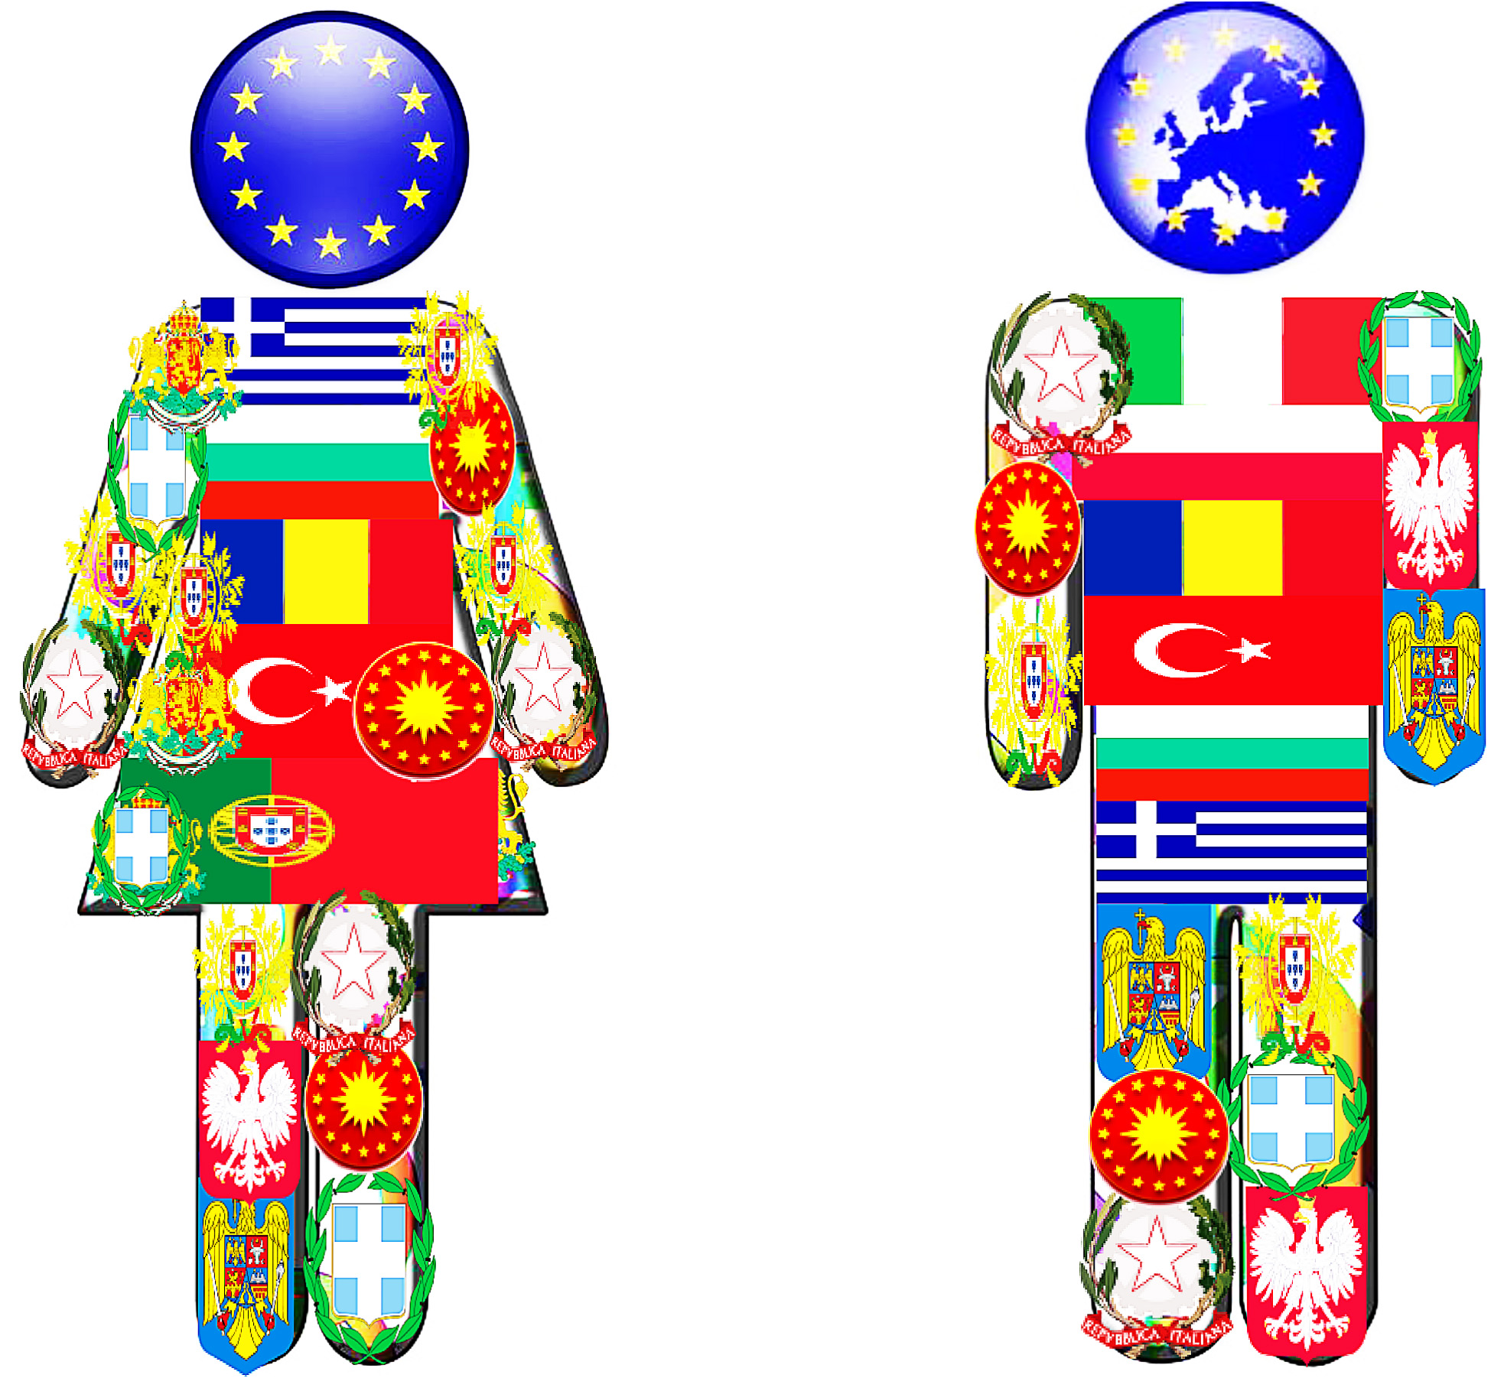



### **Intercultural Competences Across The School Curriculum**

[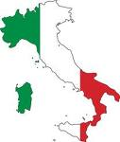](file:///H:\imgres%3fimgurl=http:\mapsof.net\uploads\static-maps\italy_looking_like_the_flag.png&imgrefurl=http:\mapsof.net\italy\static-maps\png\italy-looking-like-the-flag&usg=__LIZea8RXBCAfoa6LHi5S7EzoNCg=&h=1064&w=902&sz=21&hl=el&start=38&zoom=1&tbnid=Dw9IxsGhmIcf7M:&tbnh=150&tbnw=127&ei=TgLgTY2KH4-FswbY6MG1BQ&prev=\search%3fq=flag+of+italy&start=20&um=1&hl=el&sa=N&tbm=isch&um=1&itbs=1)[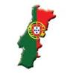](file:///H:\imgres%3fimgurl=http:\www.directferries.co.uk\image\flagmaps\portugal_map_flag.jpg&imgrefurl=http:\www.directferries.co.uk\portugal.htm&usg=__XrvKqV5BOyKhnTSnfAUa5X4X4io=&h=160&w=160&sz=12&hl=el&start=197&zoom=1&tbnid=fEM_Zl66DMoQVM:&tbnh=98&tbnw=98&ei=lALgTeavKI_Fswa-8sm1BQ&prev=\search%3fq=flag+of+portugal&start=180&um=1&hl=el&sa=N&tbm=isch&um=1&itbs=1)

[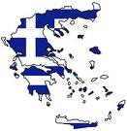](file:///H:\imgres%3fimgurl=http:\3.bp.blogspot.com\_xSUb4Zf5zzA\TEpLz2n_BlI\AAAAAAAABkA\gUsKV-C-xOA\s1600\581px-Flag-map_of_Greece.svg.png&imgrefurl=http:\odoiporoi.blogspot.com\2010\07\blog-post_5843.html&usg=__laDgk_7R_v_RFuoFIx4-SBYtxIk=&h=599&w=581&sz=78&hl=el&start=48&zoom=1&tbnid=lin0Ex6PwD69iM:&tbnh=135&tbnw=131&ei=5QHgTaD2AYLetAaPj-zfBQ&prev=\search%3fq=flag+of+greece&start=40&um=1&hl=el&sa=N&tbm=isch&um=1&itbs=1)[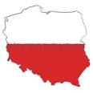](file:///H:\imgres%3fimgurl=http:\www.vectorology.com\images\Flag_Map_Of_Poland.png&imgrefurl=http:\www.vectorology.com\shop\item.aspx%3fitemid=515&usg=__HHW0oJtULk2Ut6eWnfd7mbT8CcY=&h=300&w=300&sz=8&hl=el&start=84&zoom=1&tbnid=XtEdBKcVMFnVmM:&tbnh=116&tbnw=116&ei=HgLgTdGpNomAswaD6L25BQ&prev=\search%3fq=flag+of+poland&start=80&um=1&hl=el&sa=N&tbm=isch&um=1&itbs=1)[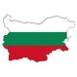](http://www.vectorology.com/images/Flag_Map_Of_Bulgaria.png)

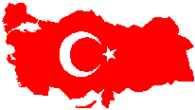[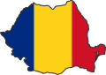](file:///H:\romania\static-maps\png\romania-stub)

